Welcome

Jo Hameleers

jo@hameleers.com

Born on May 2, 1950 in Maastricht. Lives and works in Amsterdam. He still has not a notion of his true destiny on this planet. According to him the true nature of art is only to be found in magic, religion and ritual. The people in his paintings are lost in a strange universe or pictured as clumsy, almost funny creatures. Do not only see his fluent brush and bright colours. Look. It's only by looking that something happens.

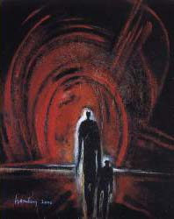
Exhibitions

1987 In de Moriaan/ Maastricht (solo)
1991 Eijlders/ Amsterdam (solo)
1992 Gezondheidscentrum Diemen-Noord/ Diemen (solo)
1993 Hoofdkantoor Postbank/ Amsterdam (solo)
1994 De Smederij/Groningen (solo)
1994 Euro Art Gallery/ Almere (solo)
1994 Euro Graphic Services/ 's-Hertogenbosch
1995 UN-Expedition, South Pole/ Antarctica
1995 Krull/ Amsterdam (solo)
1996 Hermitage Arts Gallery/ Amsterdam
1996 Krull/ Amsterdam (solo)
1996 De Smederij/ Groningen (solo)
1996 Galerie Zum Grabeneck/ Basel
1996 Galerie Zwei/ Basel
1996 Open Ateliers De Pijp/ Amsterdam
1997 Galerie Ruth Klein/ Basel
1998 Galerie Artisart/ Maastricht
1998 Spring Fair/ Driehuis
1998 Art Attack/ Amsterdam
1998 De Kamer/ Emmen (solo)
1999 Galerie Artisart/ Maastricht (solo)
1999 Krull/ Amsterdam (solo)
1999 Ambient Art Gallery/ Amsterdam (solo)
1999 Open Ateliers de Pijp/ Amsterdam
1999 PAN-Rai/ Amsterdam
1999 Contemporary Art Fair Twente/ Hengelo
1999 Galerie Art Meets Woerden/ Woerden (solo)

2000 Gezondheidscentrum Diemen-Noord/ Diemen (solo)
2000 Galerie Artisart/ Maastricht (solo)
2000 Galerie De Maagd van Gend/ Amsterdam (solo)
2000 Krull/ Amsterdam (solo)
2000 Open Ateliers de Pijp/ Amsterdam
2000 Unive Verzekeringen/ Emmen (solo+catalogue)
2001 Krull/ Amsterdam (solo)
2001 Bed & Stijl/ Amsterdam (solo)
2001 Galerie De Maagd van Gend/ Amsterdam (solo)
2001 Ambient Art Gallery/ Amsterdam (solo)
2001 Kunst-Rai/ Amsterdam
2001 Ambient Art Gallery/ Amsterdam
2001 Galerie Retort/ Amsterdam
2002 Eijlders/ Amsterdam (solo)
2002 ABC-Treehouse Gallery/ Amsterdam
2002 Novotel/ Maastricht
2002 Galerie ArtisJoke/ Maastricht
2002 Galerie Artisart/ Maastricht (solo)
2002 Ambient Art Gallery/ Amsterdam (solo)
2002 Lineart-International Art Fair, Gent, Belgium.
2003 Galerie Revue/Maarssen
2003 De Kamer /Emmen (solo)
2003 Galerie Diva/Amsterdam (solo)
2004 Galerie Diva/Amsterdam
2004 Galerie Foto & Kunst/Amsterdam
2004 Galerie De Omgeving/Borger (solo)
2005 Galerie De Omgeving/Borger (solo)
2005 Nova Art Gallery/Eindhoven (solo)
2006 Nova Art Gallery/Eindhoven (solo)
2007 Amstelkerk/Amsterdam (solo)
Contact

address
Jo Hameleers
Jacob van Lennepstraat 95c
1053 HP Amsterdam
tel. +31 (0)20.616 5770
GSM +31(0)6.50668211
email: jo@hameleers.com

Atelier/Studio
Kerkstraat 324 (near Amstelkerk)
1017 HC Amsterdam
Bank: 66.37.80.225
Postbank: 3061685

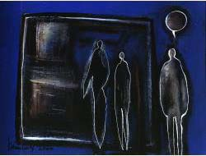
Last exhibition

FROM 12 UP TO APRIL 2007
JO HAMELEERS
SOLO EXHIBITION NEW PAINTINGS

AMSTELKERK
Amstelveld 10
1017 JD AMSTERDAM

OFFICIAL OPENING THURSDAY APRIL 12 2007
FROM 5.30 PM TO 7.30 PM
Photos studio

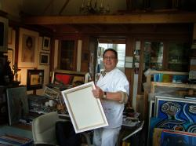

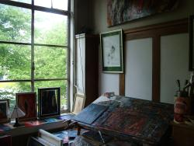

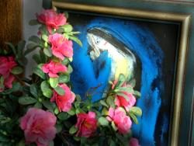
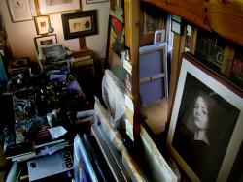

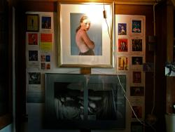

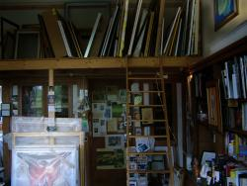
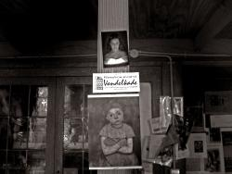

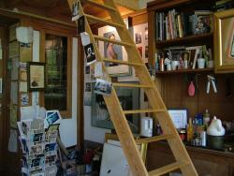

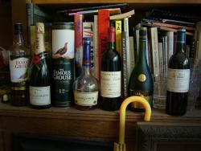

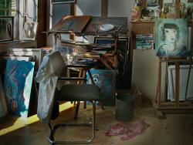

Copyright © Jaap Bijsterbosch

WARNING:

STOLEN IN FEBRUARY, 2004 FROM AN ART COLLECTION IN NORTH HOLLAND A PAINTING BY JO HAMELEERS, TITLE 'MAN LOOKING AT THE BLUE PLANET' ACRYL ON BOARD, 30x40 CM
(PUBLISHED IN THE UNIVE CATALOGUE 2000)

IF SPOTTED SOMEWHERE: PLEASE MAIL TO
JO@HAMELEERS.COM

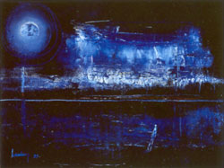

MAN LOOKING AT THE BLUE PLANET
Colofon

Photography:
Studio Hendrik Kerstens, Amsterdam
Studio Elisah Bangoura, Tilburg
Studio Jaap Bijsterbosch, Amsterdam:
www.oogenblikjaap.blogspot.com

Webdesign:
Roland Muller (rolandm@xs4all.nl), Amsterdam

Advisors:
Jurjan de Vries, Krommenie
Peter Zynda, Berlin
Frans Peeters, Amsterdam

